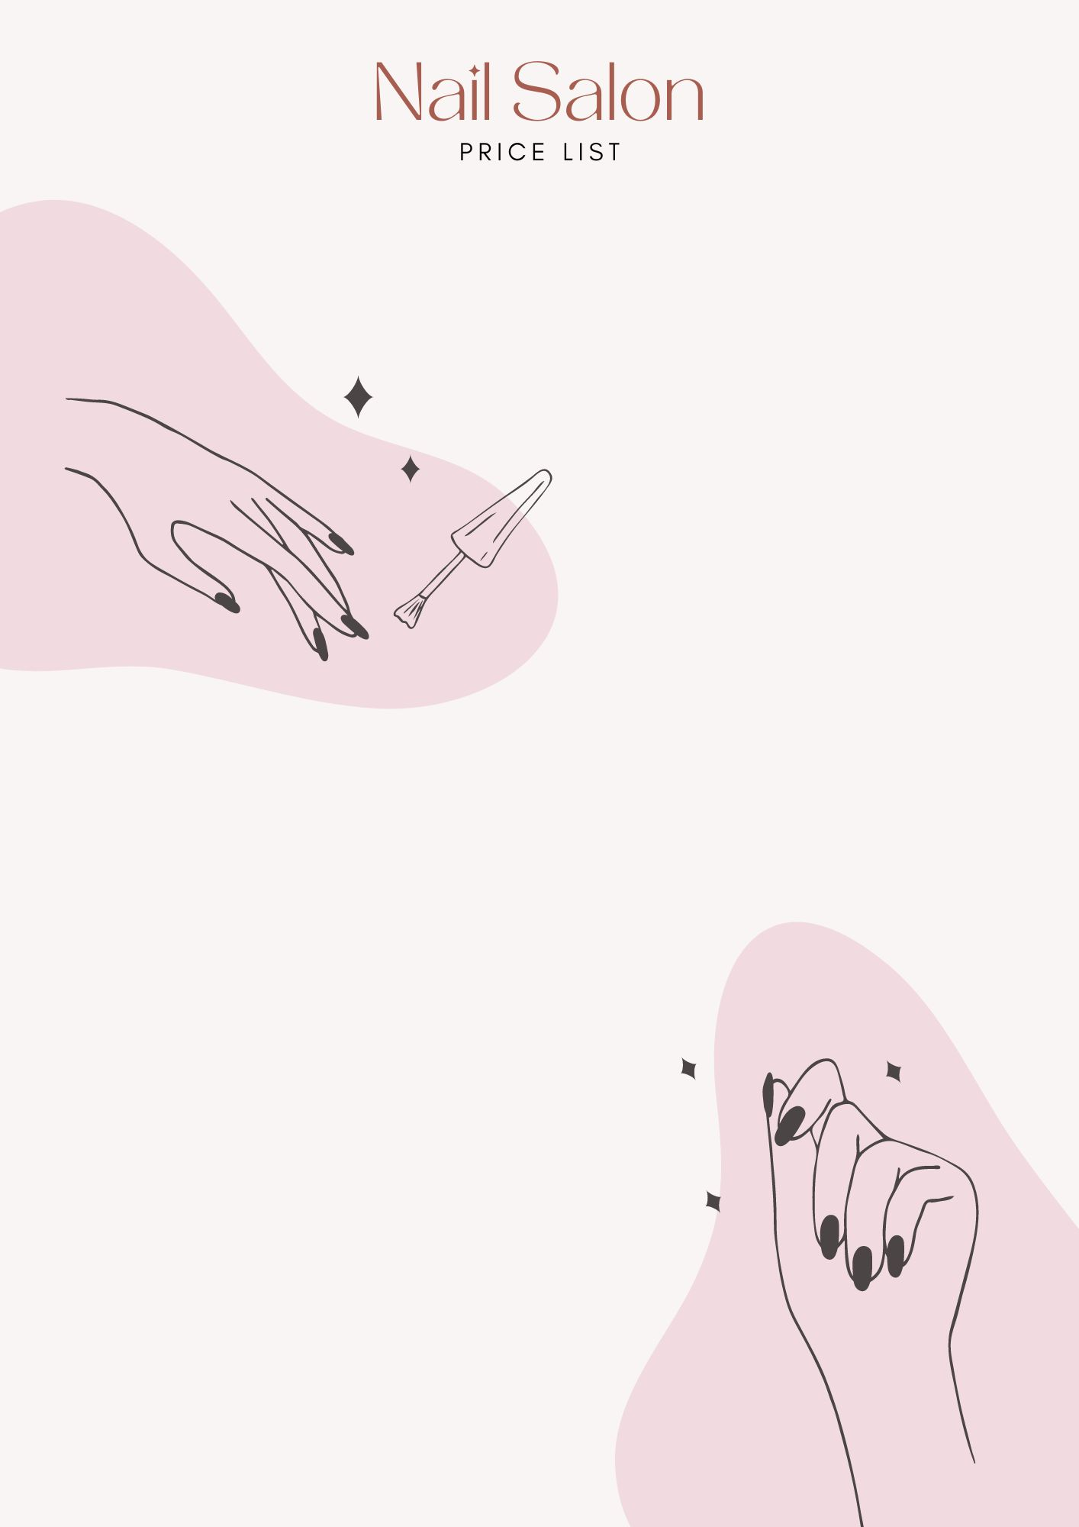

Manicure
Manicure (American) ……………………………… $00
Express Manicure (Gel American)……………. $00
Manicure (French) …………………………….……. $00
Express Manicure (Normal French) ….…….. $00
Kids Manicure….…….………………………….……. $00
Luxury Manicure (Gel French) …………..……. $00

Pedicure
Classic Pedicure (Gel)….…………………………… $00
Classic Pedicure (American)..…..……………… $00
Kids Pedicure …………….…………………………… $00
Luxury Slush Pedicure…………………..………… $00
Dry Express Pedicure…………………..…………. $00

Nail Repair
Shellac/Gel Removal ....…………………………… $00
Nail Enhancements…….…………………………… . $00
Repair Nail Enhancements (Per Nail)……….. $00

[Your Business Name]
+1 234 567 890
www.huguetemplate.net

