
Report Card



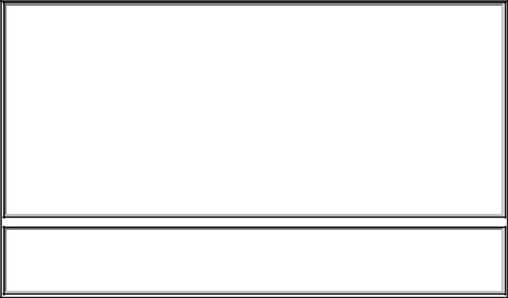

Name: _______________________________________

Class: _______________________________________

Your child as a learner

Rarely | Sometimes | Most ofthetimeAlways

Interested in learning

Listens attentively

Works well independently

Works well with other children

Keeps trying even when tasks are difficult

Homework is of high quality

Presents work carefully

Your child’s social and personal development

Rarely | Sometimes | Most ofthetime | Always

Happy at school

Behaves well in class

Mixes well with other children

Sensitive to others’ feelings

Behaves well in the playground

Manages and expresses own feelings well

Your child’s learning during the year

- Experiencing significant difficulty

- Experiencing some difficulty ★ Managing comfortably
- Capable and competent ★ Highly capable and competent

English | ★ | ★ | ★ ★ ★

Listening comprehension

Oral expression

Reading

Written expression

Gaeilge | ★ | ★ | ★ ★ ★

Listening comprehension

Oral expression

(Pre) Reading

(Pre) Writing

Mathematics | ★ | ★ | ★ ★ ★

Understanding and recalling

Using procedures

Reasoning and problem solving

Explaining and communicating

Social, Environmental and | ★ | ★ | ★ ★ ★
Scientific Education | ★ | ★ | ★ ★ ★

History

Geography

Science

Arts Education | ★ | ★ | ★ ★ ★

Music

Drama

Visual Arts

★ ★ ★ ★ ★

Physical Education

Social, Personal & Health

Education

Religious/Ethical Education

How you can further support your child's learning
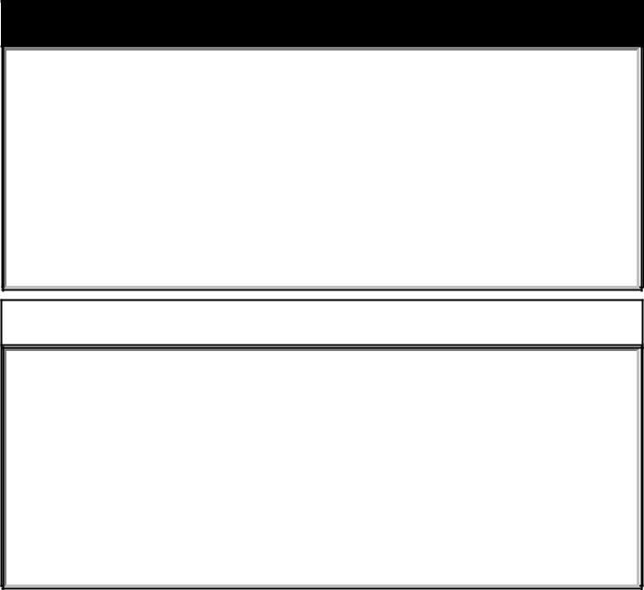

Standardised test results (if applicable)


Comments

Attendance | Punctuality

Teacher:____________________________________

Principal: ___________________________________

Date: ______________________________________

