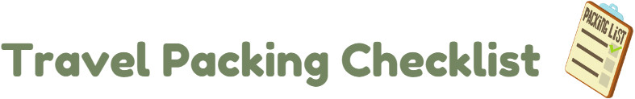**Documentation**

* Driver’s License
* Birth certificate (if needed)
* Visa/Passport
* Immunization records
* Tickets
* Map
* Itinerary
* Travel guide

**Laundry**

* Laundry bag
* Detergent
* Stain remover
* Fabric Softener/Dryer Sheets
* Coins
* Sewing kit
* Hangers

**Children items**

* Snacks & Wipes
* Clothes/Socks/Shoes
* Coats/Hats/Gloves
* Sleeping bags/Pillows
* Games/Toys
* Books
* Coloring books/Crayons
* Sports equipment

**Before Leaving**

* Enable alarm system, set up light timers
* Arrange for care of home/pets
* Pay any bills that may become outstanding while you’re gone
* Set up your out-of-office email response at work
* Lock up home, doors, and windows

**Money**

* Wallet/Purse
* Debit card/Credit card
* Cash
* Checks/Travelers checks

**Clothing**

* Casual shirts/T-shirts
* Casual pants/Shorts
* Dress shirts/Dress pants
* Pajamas/Robe/Slippers
* Sweaters
* Underwear
* Socks
* Casual shoes/Sandals
* Dress shoes
* Hats/Scarves/Gloves
* Belts
* Jackets/Coats/Sweaters
* Swimwear
* Workout clothes/shoes
* Suits
* Sports Coat
* Ties/Suspenders
* Skirts/Dresses
* Bras
* Girdle/Bodysuit/Slip
* Nylons

**Medical/Health**

* Prescriptions
* Allergy medication
* First Aid kit
* Vitamins
* Hand sanitizer/Antibacterial wipes
* Sunscreen
* Pain medication
* Insect repellant

**Electronics**

* Phone and accessories (charger, Bluetooth, case)
* Camera and accessories (charger, extra film/chip)
* Laptop and accessories (charger, extra battery, case)
* DVD Player/DVDs
* Music player
* PDA
* GPS system

**Toiletries**

* Toothbrush/Toothpaste
* Dental floss/Picks
* Mouthwash
* Glasses/Case/Contacts/Solution
* Q-Tips/Cotton Balls
* Tweezers/nail clippers
* Deodorant
* Shampoo & Conditioner
* Soap/Body Wash
* Washcloth
* Brush/Comb
* Gel/Hairspray/Hair Products
* Mirror
* Tissue
* Lotion/Lip balm
* Razor/Shave Gel/Aftershave
* Cologne
* Cosmetics
* Facial cleanser
* Pads/Tampons
* Curling Iron/Flat Iron
* Blow dryer/Diffuser
* Hair Accessories
* Razor/Shave gel
* Perfume